For Immediate Release

The Symetra Tour’s Murphy USA El Dorado Shootout presented by PepsiCo Announces Three-Year Extension

Murphy USA and the Symetra Tour announce extended three-year commitment and 2018 El Dorado Shootout dates

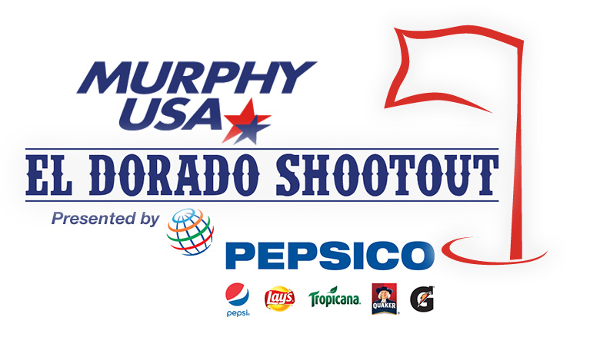
EL DORADO, AR, April 3, 2018 – Murphy USA is excited to announce an extended commitment to the Symetra Tour, adding the Murphy USA El Dorado Shootout to the Tour schedule through 2020. Since hosting the first El Dorado Shootout Tournament in 2015, this event has become a favorite among both the female athletes on the Tour and those living in the South Arkansas community.

The 2018 Murphy USA El Dorado Shootout presented by PepsiCo will be held September 14 through 16 at Mystic Creek Golf Club in El Dorado. Numerous activities will occur throughout the week leading into the Tournament, including a Junior Clinic for children ages six to eighteen and Pro-Am scrambles that pair Symetra Tour professionals with various local and national sponsors.

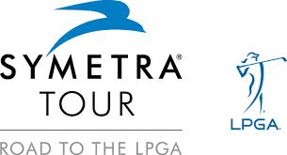
This September will mark the fourth year that Murphy USA and the El Dorado community will host the 54-hole stroke-play format event, which was recently recognized as the 2017 Sporting Event of the Year by the Arkansas Festivals & Events Association. Each year, the El Dorado Shootout welcomes a player field comprised of the top aspiring female professional golfers from around the world. Competitors will vie for a $150,000 total purse, where the winner will earn $22,500 and take a significant step toward obtaining her LPGA Tour Card for the 2019 season. The top 10 players on the year-end Volvik Race for the Card money list receive their full-time LPGA Tour Cards for the following season. Symetra Tour players have gone on to win 428 LPGA Tour events, including 46 major championships.

Not only does hosting this high-profile professional Tournament provide El Dorado with a valuable platform to showcase its incredible downtown, restaurants, and entertainment venues; it is also an important way for these young women to pursue their dreams of professional golf success. This event also provides the opportunity to give back to the community, as each year one El Dorado charity is chosen to benefit from the Tournament.

The Symetra/El Dorado Shootout Committee looks forward to working with Mystic’s new General Manager/PGA professional, David Cage, during the Tournament. Cage brings a wealth of experience to Mystic including roles at prestigious properties in Florida, California, South Carolina, and Colorado.
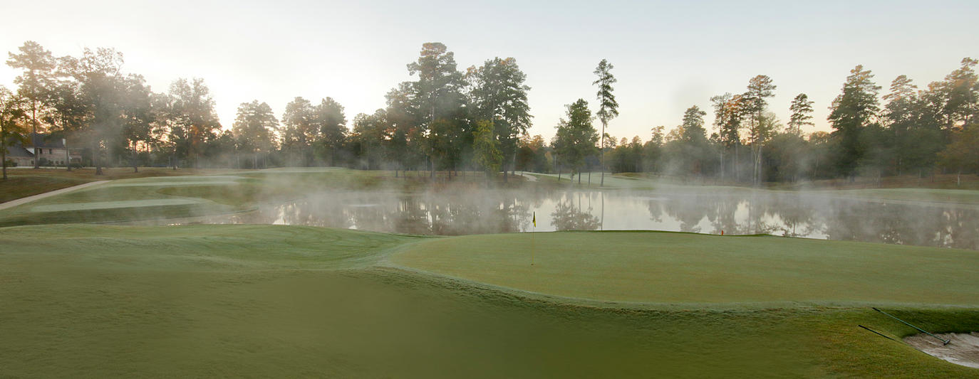
Mystic Creek Golf Club was designed by acclaimed golf architect Ken Dye. The par-72 course with its Champion Bermuda greens and Celebration Bermuda fairways is considered challenging. Many of the Symetra Tour athletes describe Mystic as the best course they play all year and respect its level of difficulty.

For more information about the Murphy USA El Dorado Shootout visit the Tournament’s website at www.eldoradoshootout.com.

About the Symetra Tour
The Symetra Tour is the official qualifying tour of the LPGA Tour and enters its 38th competitive season in 2018. With the support of its umbrella partner Symetra, the Tour’s mission is to prepare the world’s best young women professional golfers for a successful career on the LPGA Tour. Since Symetra’s inaugural sponsorship year in 2012, the Symetra Tour has grown from 16 tournaments and $1.7M in prize money to $3M in prize money awarded over the course of 22 tournaments. With more than 600 alumnae moving on to the LPGA, former Symetra Tour players have won a total of 427 LPGA titles. Follow the Symetra Tour on the web at www.SymetraTour.com, Facebook.com/RoadtotheLPGA, Twitter.com/Road2LPGA, and YouTube.com/Road2LPGA.

About Murphy USA
Murphy USA is a leading retailer of gasoline and convenience merchandise with more than 1,400 stations located primarily in the Southwest, Southeast and Midwest United States. The company and its team of over 9,000 employees serve an estimated 1.6 million customers each day through its network of retail gasoline stations in 26 states. The majority of Murphy USA's sites are located in close proximity to Walmart stores. The company also markets gasoline and other products at standalone stores under the Murphy Express brand. Murphy USA ranks 291 among Fortune 500 companies.

Media Contact
Susan Ables
El Dorado Shootout Media
susan@eldoradoshoout.com
870-837-2500

